**“LAB MST Experiment”**

|  |  |
| --- | --- |
| **Submitted By: SUMIT KUMAR**  **UID:20BCS8226** | |
| **Subject Name** | COMPETETIVE CODING |
| **Subject Code** | 20CSP-314 |
| **Branch** | BE-CSE |
| **Semester** | 5th |

**Aim/Overview of the practical:**

Complete given Array questions on Hackerrank platform.

Task 1:

You are given Q queries. Each query consists of a single number N. You can perform any of the operations on in each move:

1. If we take 2 integers a and b where N=a*b (a, b cannot be equal to 1), then we can change N=max(a, b)
2. Decrease the value of N by 1.

Determine the minimum number of moves required to reduce the value of to.

**Steps for experiment/practical/Code:**

#include <bits/stdc++.h>

using namespace std;

int dis[1000002];

int main()

{

int n,que;

cin>>que;

while (que--)

{

cin>>n;

if(n == 0)

{

cout<<0<<endl;

continue;

}

queue<int> q;

q.push(n);

dis[n] = 1;

while (!q.empty())

{

int now = q.front();

q.pop();

if(dis[now-1] == 0)

{

dis[now-1] = dis[now]+1;

if(now -1 == 0)

break;

q.push(now-1);

}

for(int i = 2; i*i <= now; i++)

{

if(now%i == 0)

{

int fac = max(i, now/i);

if(dis[fac] == 0)

{

dis[fac] = dis[now]+1;

q.push(fac);

}

}

}

}

cout<<dis[0]-1<<endl;

memset(dis,0,sizeof(dis));

}

return 0;

}

**Time Complexity- O(n)**

**Result/Output/Writing Summary:**

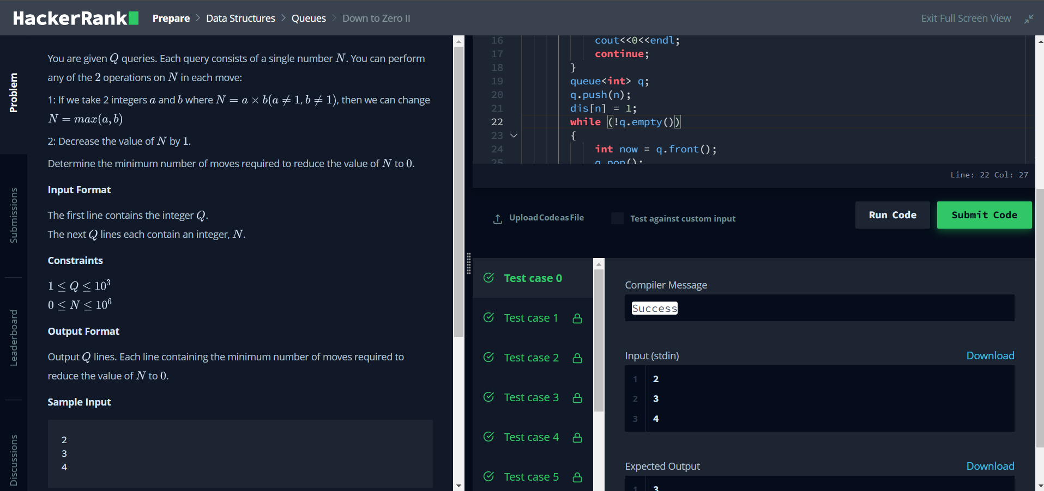

**Task 2:**

Suppose there is a circle. There are N petrol pumps on that circle. Petrol pumps are numbered 0 to (N-1) (both inclusive). You have two pieces of information corresponding to each of the petrol pump: (1) the amount of petrol that particular petrol pump will give, and (2) the distance from that petrol pump to the next petrol pump.

Initially, you have a tank of infinite capacity carrying no petrol. You can start the tour at any of the petrol pumps. Calculate the first point from where the truck will be able to complete the circle. Consider that the truck will stop at each of the petrol pumps. The truck will move one kilometer for each litre of the petrol.

**Algorithm:**

**START**

**STEP 1:** Take a variable tank with initial size 0 and update its value by differentiating the value of next station distance and amount of gas it provides.

**STEP 2:** If the value of tank reduces to a negative value then update its value to 0 because now the truck cant move further from that station and also take the starting gas station to the next coming station.

**END**

**Steps for experiment/practical/Code:**

int truckTour(vector<vector<int>> petrolpumps) {

int tank=0,start=0;

for(int i=0;i<petrolpumps.size();i++)

{

tank+=petrolpumps[i][0]-petrolpumps[i][1];

if(tank<0)

{

start=i+1;

tank=0;

}

}

return start;

}

**Time Complexity- O(n)**

Where n is the size of the array petrolpumps

**Result/Output/Writing Summary:**

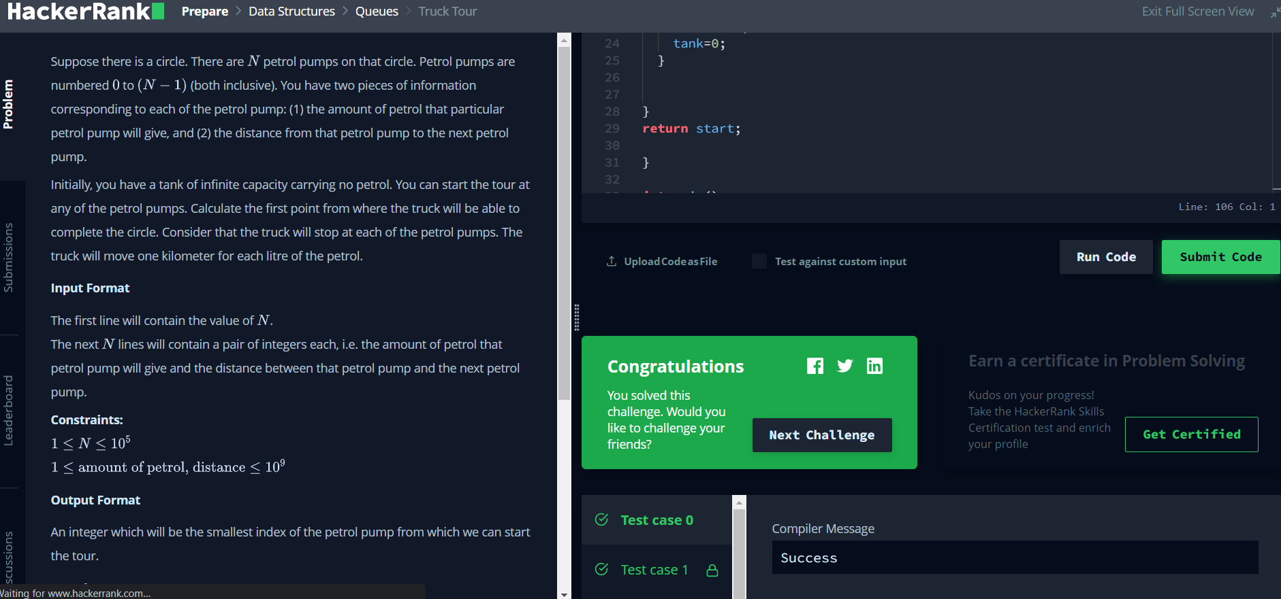

**Evaluation Grid (To be created as per the SOP and Assessment guidelines by the faculty):**

|  |  |  |  |
| --- | --- | --- | --- |
| Sr. No. | Parameters | Marks Obtained | Maximum Marks |
| 1. |  |  |  |
| 2. |  |  |  |
| 3. |  |  |  |